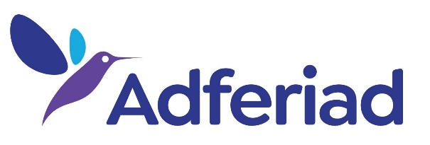
ADFERIAD RECOVERY

How to make a complaint

adferiad.org

Please read this booklet if you are unhappy with any of Adferiad Recovery’s services and you want to make a complaint.

You can also write to us with other comments, for example to let us know you are pleased with our service or to share your suggestions on how Adferiad Recovery’s services could be improved.

Complaints provide Adferiad Recovery with the opportunity of trying to put things right. They also give us information about how we can improve our services. On that basis we welcome your complaint and will seek to resolve matters as quickly as possible.

If you complain:

You will be treated with respect
You will be listened to
You will not have services withdrawn as a consequence
You will not be labelled as a troublemaker
You will be kept informed about the progress of your complaint

How can I complain?

You can complain by:
Talking face to face with a member of staff
Telephone
Writing a letter or completing a complaint form
Sending an email

Can I get help to complain?

Yes, a friend, relative or carer can help you. However, we will need your written permission for them to act on your behalf.

We can also give you information about how to contact local advice or advocacy agencies, which can help you make your complaint.

About this booklet

This booklet sets out Adferiad Recovery’s policy and procedure for addressing complaints and provides information to people who use Adferiad Recovery services, funding bodies and other stakeholders on how to make a complaint. Guidance to Adferiad Recovery staff on what is expected of them at each stage is also included below.
If you are unsure of anything in this booklet, please speak to local Adferiad Recovery staff or you can contact Adferiad Recovery’s Company Secretary on 01492 863000, by e-mail on feedback@adferiad.org or by post at Adferiad Recovery Head Office, Tŷ Dafydd Alun, 36 Princes Drive, Colwyn Bay, Conwy, LL29 8LA.

Reminder to Adferiad Recovery staff – copies of this booklet must be on display in your service.

How will Adferiad Recovery deal with my complaint?

Adferiad Recovery staff are trained to respond to any complaint and we have a three stage approach to handling such matters.

Reminder to Adferiad Recovery staff – if you are unsure of your responsibilities within this policy and procedure contact your line manager.

Stage 1 – Local Resolution – Informal

Adferiad Recovery wants to deal with your complaint quickly and effectively. Therefore, we will try and resolve it on a local level.

Please discuss your complaint with the person involved, or the person in charge if you prefer (you can ask someone else to help you with this if you wish). Please be clear that you are making a complaint and give the people involved a chance to respond to you.

If a member of staff cannot resolve your complaint immediately, the person managing the service will contact you to try to resolve your complaint. The local staff or the person managing the service will meet with you to respond to your complaint.

Reminder to Adferiad Recovery staff – any complaint is an opportunity to address areas of concern within a project. If you receive a complaint, make time to address it; meet with the complainant as soon as possible and listen carefully to their concerns being honest and open about any problems and how they may be overcome and make notes of the reason for the complaint and any resolution. Do not be afraid to seek advice or support from line managers. Report all complaints, even if resolved informally, to your line manager as soon as possible.

Stage 2 – Formal Investigation

If you are not satisfied with how Adferiad Recovery has responded to your complaint locally, you have the right to go to Stage 2, by writing to Adferiad Recovery’s Company Secretary at Adferiad Recovery’s Head Office, within 14 days of the meeting with local staff.

The Company Secretary will acknowledge your complaint within 3 working days and will appoint an Investigating Officer. This will be an Adferiad Recovery member of staff who is not connected to your complaint. The Investigating Officer will speak to you and anyone else involved in the complaint.

The Company Secretary will consider the recommendations of the investigation and advise you in writing of the outcome.

Reminder to Adferiad Recovery Staff – The Investigating Officer should contact the complainant as soon as possible to obtain all the relevant information. Notes from Stage 1 should be reviewed and information sought from appropriate sources. A meeting may be useful with the complainant and should be offered if appropriate in an effort to resolve the matter.

Stage 3 – Appeal

If you are not satisfied with the outcome of Stage 2, you can appeal in writing to the Chief Executive, within 14 days of receiving the letter informing you of the outcome of Stage 2.

The Chief Executive will acknowledge your complaint within 5 working days and will nominate a Adferiad Recovery Manager unconnected with the matter to address the appeal (Appeal Officer).

The information Adferiad Recovery has gathered about your complaint and how we have tried to resolve it will be reviewed. The points you raise in your appeal will be looked at in detail. The Appeal Officer will report to the Chief Executive, usually within 10 days, who will contact you in writing to inform you of the outcome of your appeal within a further 10 days.

Reminder to Adferiad Recovery Staff – see notes at Stage 2.

How we approach complaints

The person handling the complaint will investigate by looking at written evidence and (where appropriate) talking to some or all of the people concerned. The written reply to your complaint (at Stage 2 and Stage 3) will include an explanation of how the investigation was carried out as well as giving you a reasoned decision on your complaint.

We want to keep things simple and respond quickly so the reply you receive will often be the single written record of the investigation and decision but if there are other records or statements written as part of the investigation that will be explained in the letter.

Note: If your complaint is regarding services provided under the Care Standards Act 2000 you may wish to contact the Care Inspectorate Wales (CIW), Welsh Government Office, Sarn Mynach, Llandudno Junction, LL31 9RZ. We would of course ask that you raise the issue first with Adferiad Recovery but you are not obliged to do so.
You may also contact your local Social Services department to access their complaints procedure. The next page provides a more concise breakdown of the procedure.

The stages of your complaint

STAGE 1

Complaint received verbally, in writing, by e-mail or on a complaint form.

You will receive an acknowledgement within 5 days of the complaint being received.
The service will try to resolve your complaint within 10 days of the complaint being received.

STAGE 2

If you are not satisfied with how Adferiad Recovery has tried to resolve your complaint informally, you can write to the Company Secretary asking for the complaint to go to Stage 2, within 14 days of the meeting with local staff informing you of the outcome of Stage 1.

The Company Secretary will acknowledge your complaint within 3 working days and will arrange for an investigation to be conducted, which will be usually be completed within 10 days. Once the investigation has been completed the Company Secretary will write to you within a further 10 days advising you of the outcome.
STAGE 3

If you are not satisfied with the outcomes of STAGE 2 you can appeal in writing to the Chief Executive, within 14 days of receiving the letter informing you of the outcome of Stage 2. The Chief Executive will acknowledge your complaint within 5 working days.

Your appeal will be considered usually within 10 days.

You will be informed in writing of the outcome of the appeal within a further 10 days.
This is the final stage of Adferiad Recovery’s complaints procedure.

Complaint Form

Name

Email Address

Address
Your Phone Number
Day Evening

What service is the complaint about?

What is your complaint?

What could we do to put things right or stop the problem happening in the future?

Continue on a separate sheet if necessary

Signature Date

You can also complain by speaking face to face to a member of staff, by telephone or email.

Marian Williams, Company Secretary, Adferiad Recovery Head Office, Tŷ Dafydd Alun, 36 Princes Drive, Colwyn Bay, Conwy, LL29 8LA
Tel: 01492 863000
Email: feedback@adferiad.org

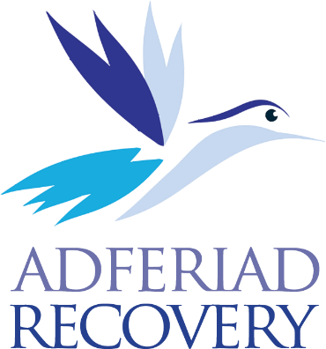
Adferiad Recovery

Bodloni anghenion pobl sy’n agored i niwed sy'n wynebu heriau bywyd cymhleth
Meeting the needs of vulnerable people facing complex life challenges
Pencadlys / Head Office Tŷ Dafydd Alun
36 Rhodfa’r Tywysog / 36 Princes Drive Bae Colwyn / Colwyn Bay
Conwy LL29 8LA

Ffôn / Tel: 01492 863000
Ebost / Email: info@adferiad.org
Web: adferiad.org.uk

Cofrestwyd y cwmni yng Nghymru a Lloegr, Rhif 2751104. Yn gyfyngedig trwy warant. Rhif elusen: 1039386 Registered Company in England and Wales, No. 2751104 Limited by Guarantee. Charity number: 1039386

